**Quick Start**

# Raspberry Pi Temperature reading

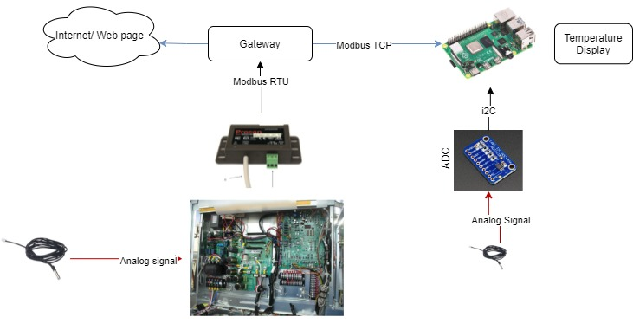

Figure 1: Raspberry Pi 3b with NTC connection

Component’s list:

* Raspberry pi 3b.
* ADS1115.
* NTC 10k.

The wiring diagram connection pins from raspberry to ADS1115:

* Pi 3V to ADS1015 VDD - Remember the maximum input voltage to any ADC channel cannot exceed this VDD 3V value.
* Pi GND to ADS1015 GND
* Pi SCL to ADS1015 SCL
* Pi SDA to ADS1015 SDA

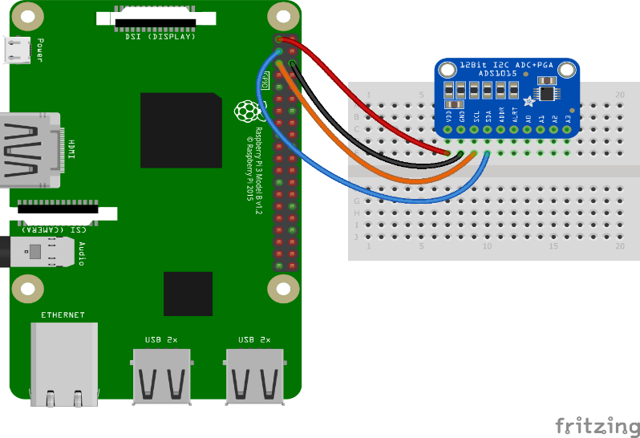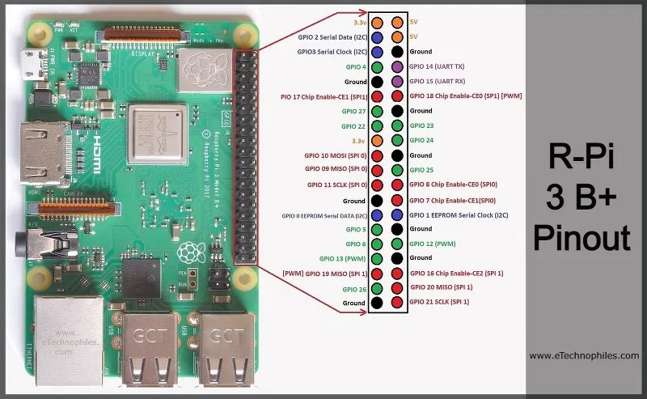

Figure 2: ADS1115 Raspberry wiring diagrams.

The thermistor NTC can connect with any pin from A0 to A3 through voltage divider circuits. The fix resistor R1 need to be selected base on the sensors value for best performance.

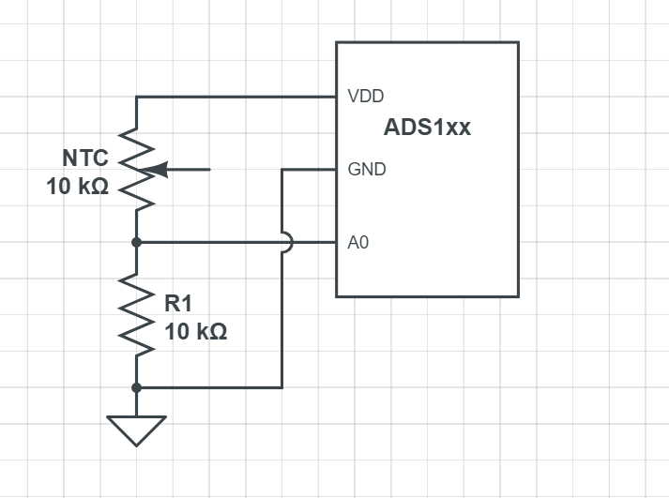

Figure 3: Thermistor analog reading with voltage divider circuit to ADS1x.

**Raspberry pi setup.**

* Power on the Raspberry Pi.
* Open the file manage and go to the directory: */home/pi/Adafruit_Python_ADS1x15/examples*
* Double click and run the *MQTT_Digitalpot_meter.py* file in figure 3.

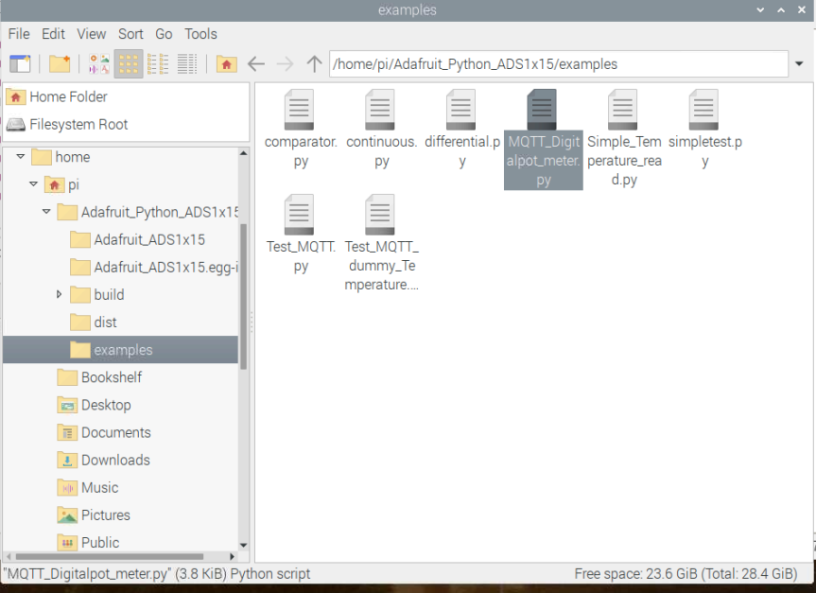

Figure 3: MQTT digital potential meter.

The programmed should print out the resistance value and the temperature value of the room temperature at that moment. For example, 10537 ohm and 23.3-degree C.

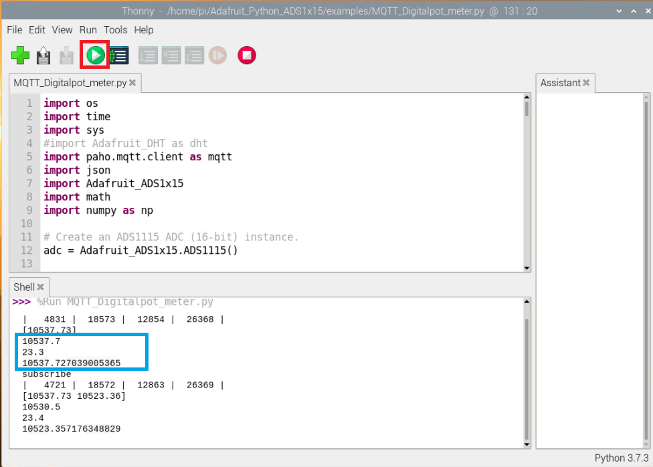

Figure 4: Resistance value and room temperature.

The resistance value and corresponding temperature can be checked with the [10k-2 thermistor output table.](https://github.com/hancse/FF_Temperature_Calibration/blob/main/Datasheet/Thermistor/Thermistor_10K-2.pdf)

**Setup the wifi to connect the Pi to the internet (figure 5,6).**

* Open the terminal and type ifconfig.
* Write down the IP address of the Pi.
* Enter the IP address with port 1880/ui into the web browser <http://192.168.50.147:1880/ui> (Remember to change it to your own address).

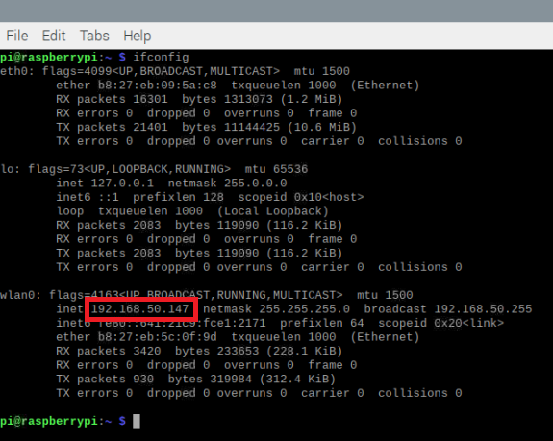

Figure 5: Raspberry Pi IP address.

Select dashboard tab user should see the updated temperature value reading in figure 6.

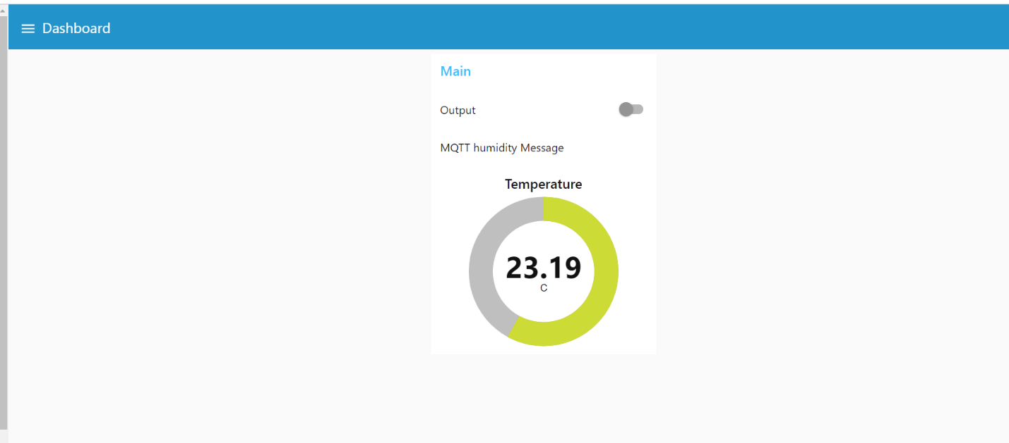

Figure 6: Temperature sensor display.

User can also use the MQTT client phone or window app using the info in figure 7 and subscribe to the *FZ/Sensor* topic to see the room temperature.

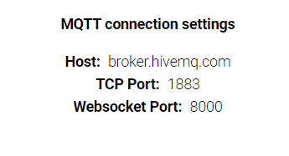

Figure 7: MQTT broker example.

# Control digital potential meter.

Component’s list:

* Arduino IOT33.
* MCP41xx_42xx.

Before getting start user should install Arduino Ide and read [Getting start with arduino IOT33](https://www.arduino.cc/en/Guide/NANO33IoT) to see how to install the supported libraries.

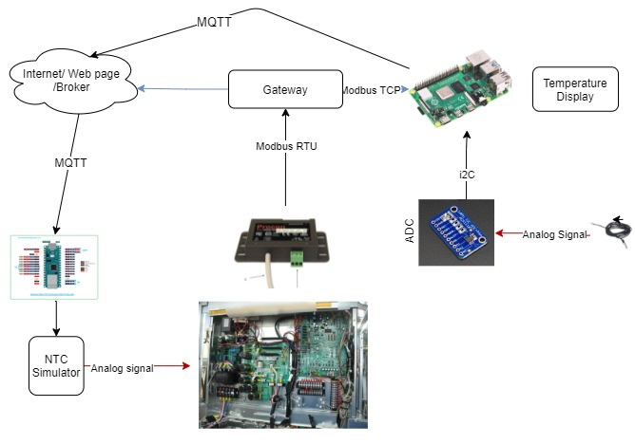

Figure 8: System overview control digital potential meters using Arduino IOT33.

.

The concept is using the raspberry pi for reading the NTC sensors and publish the temperature value through MQTT messages. The Arduino IOT33 will subscribe to the same topic and received the measured value, after that it will control the NTC simulator (*MCP41/42xx*) chip to provide the same resistance value as the NTC at that moment. The system overview shows in figure 8 and figure 9 shows the connection between Arduino IOT33 with MCP41xxx/42xxx chip. The output value is connected to the NTC terminal on heat pump PCB.

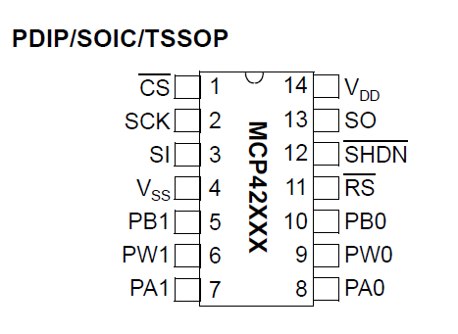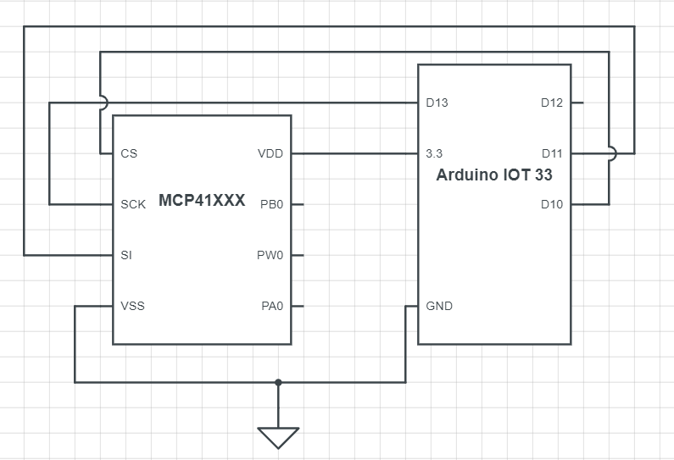

Output

Figure 9: Arduino IOT33 wiring diagrams MCP41/42xx.

The *MCPxx* device should be put on *RHEOSTAT mode on* page 14 [MCP41xxx_42xxx Datasheet](https://github.com/hancse/FF_Temperature_Calibration/tree/main/Datasheet/Digital_Potential_meter) mode of operation

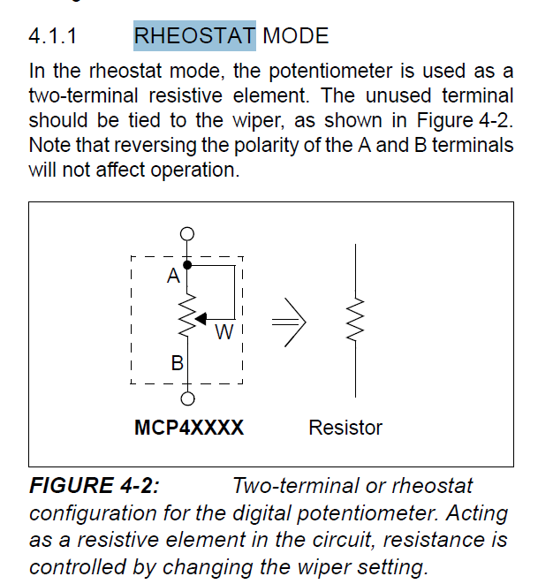

Figure 10: MCP41/42xx RHEOSTAT Mode.

Download code from github link: [IOT33 MQTT Digital Potential meters control](https://github.com/hancse/FF_Temperature_Calibration/tree/main/src/Iot33/MQTT_IOT33_MPC42050)

Flash the code to arduino IOT33 controller

Open the serial monitor of Arduino studio.

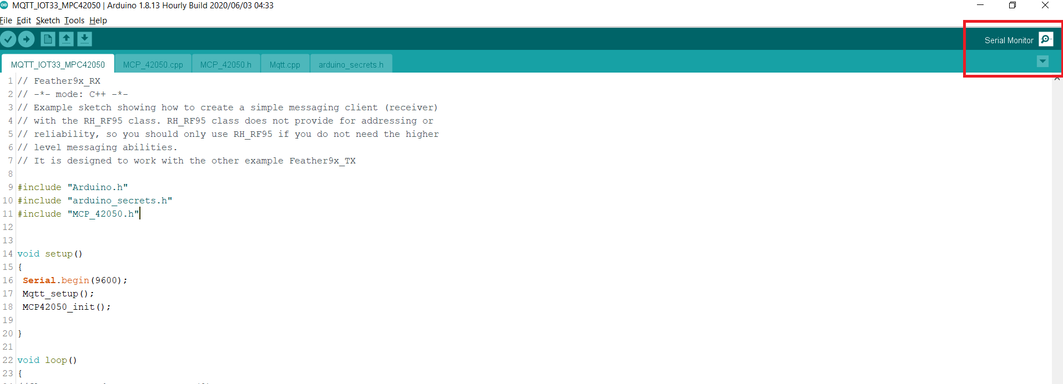

It should print out the resistance value, the wiper position and the temperature corresponding with the resistance value.

Figure 11: Open Serial Monitor.

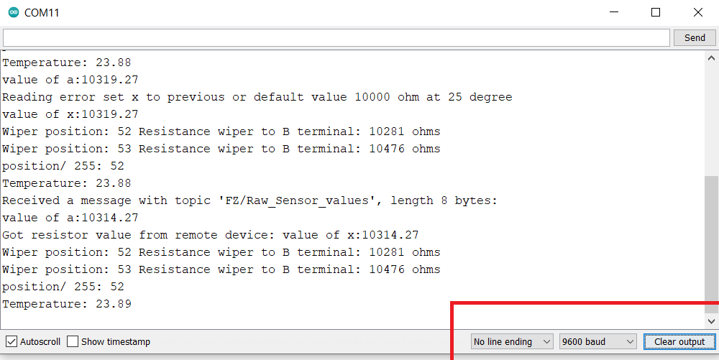

Figure 11: Serial Monitor display.

The output PBx and PAx (figure 9) can be connected to the temperature sensors pin of the Heat pump controller board.

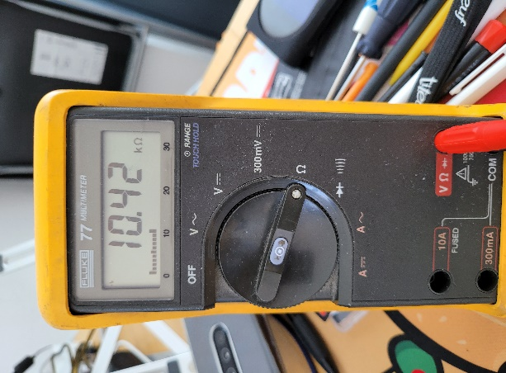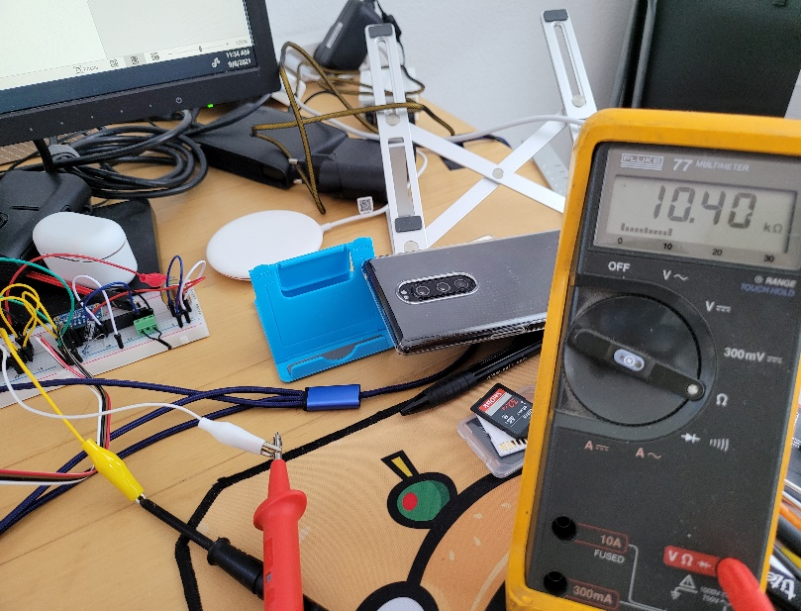

Figure 12: Checking the output value using multimeters.